Summer Reads 2018
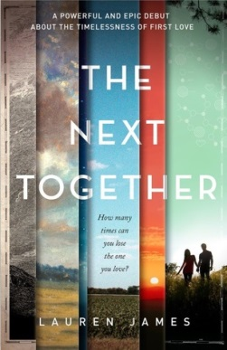
The Next Together
by Lauren James

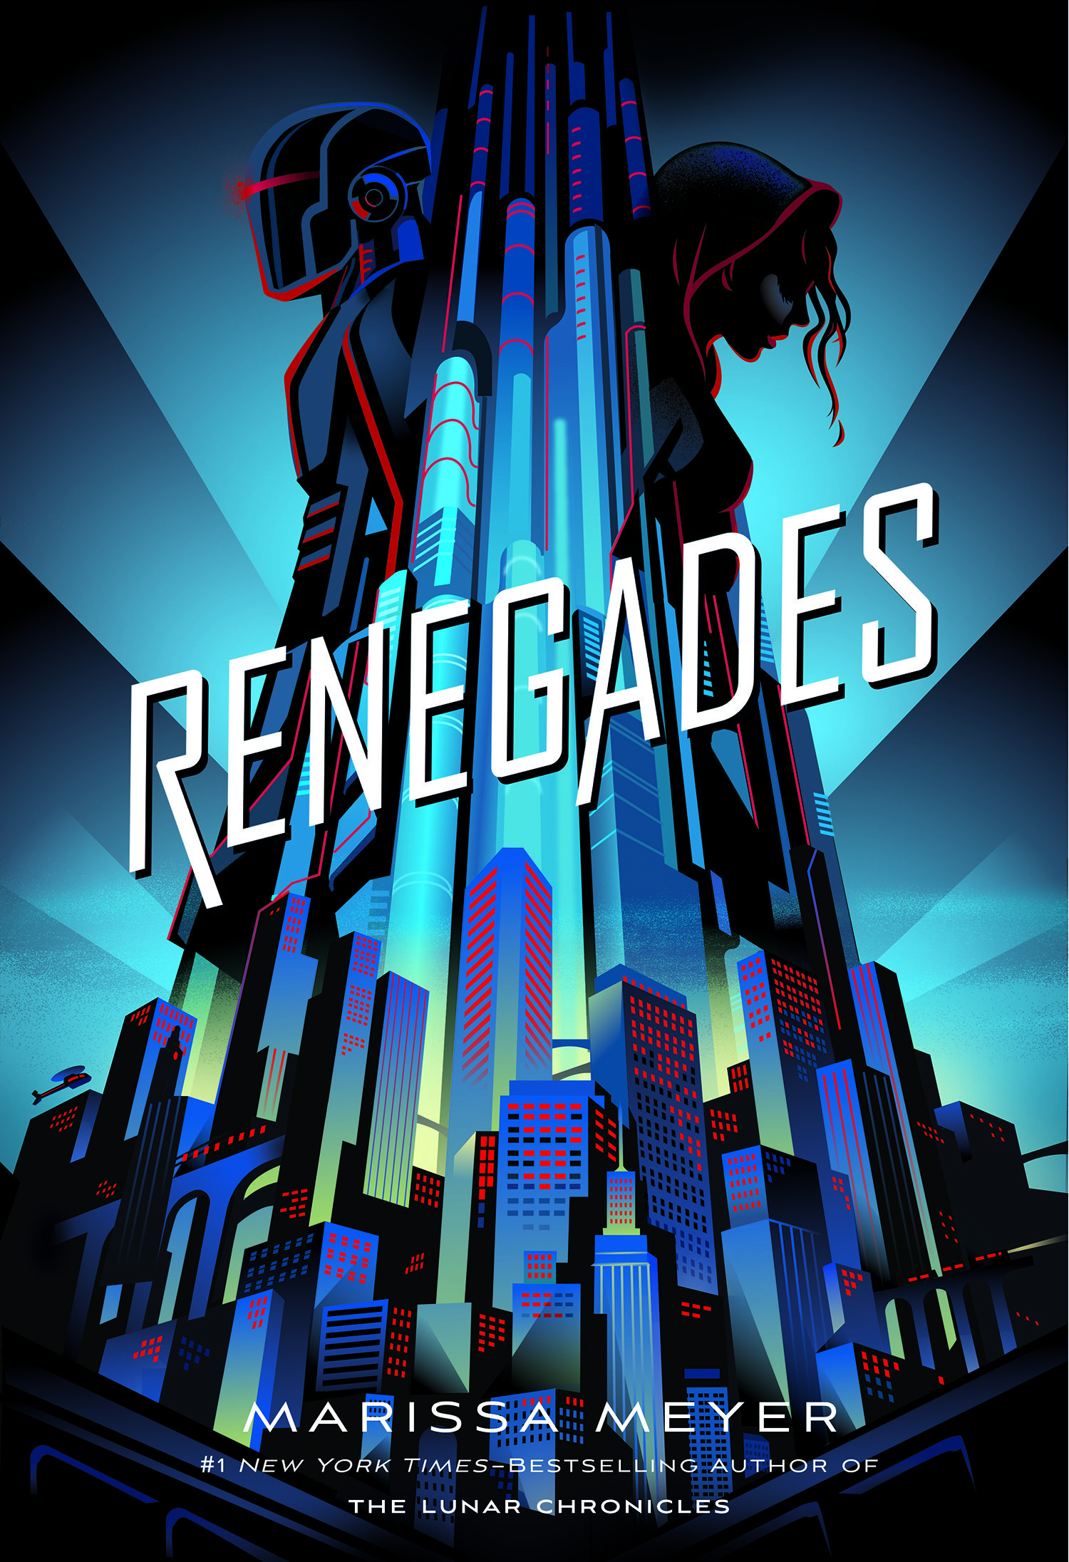
Renegades
by Marissa Meyer

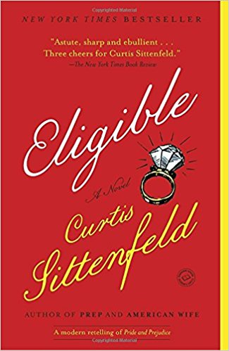
Eligible
by Curtis Sittenfeld

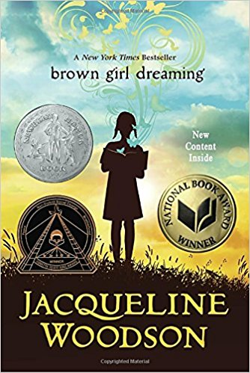
Brown Girl Dreaming
by Jacqueline Woodson

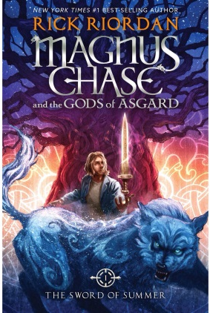

Magnus Chase and the Gods of Asgard
by Rick Riordan

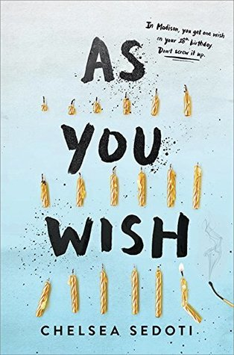
As You Wish
by Chelsea Sedoti

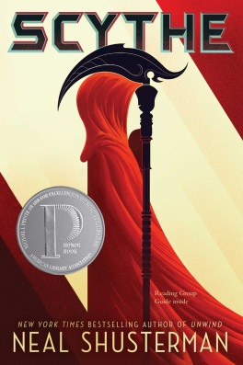
Scythe
by Neal Shusterman

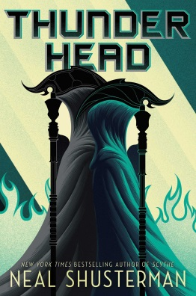
Thunderhead
by Neal Shusterman

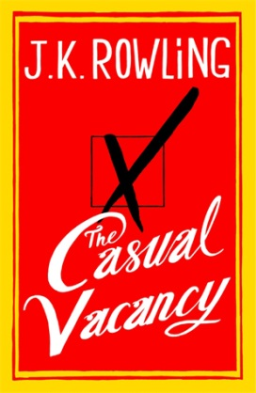
Casual Vacancy
by J.K. Rowling

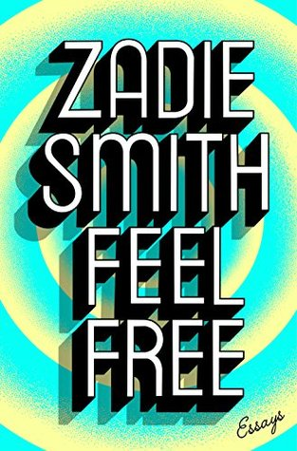

Feel Free: essays
by Zadie Smith

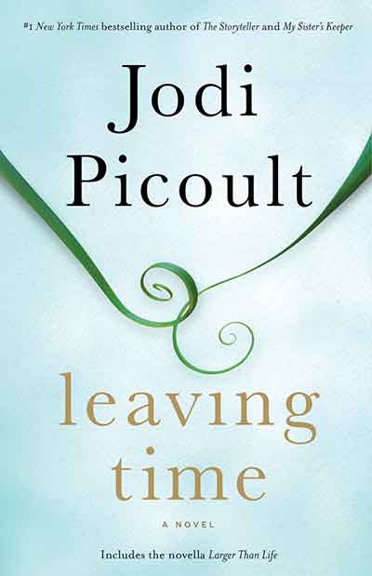
Leaving Time
by Jodie Picoult

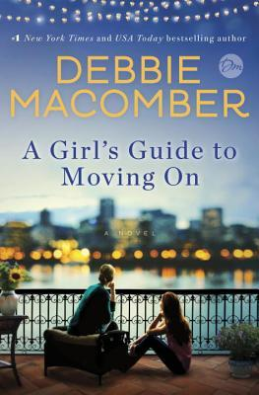
A Girl’s Guide to Moving On
by Debbie Macomber

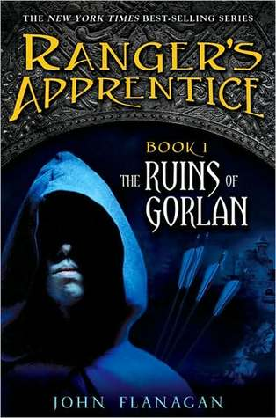
Ranger’s Apprentice Book 1: The Ruins of Gorlan
by John Flanagan

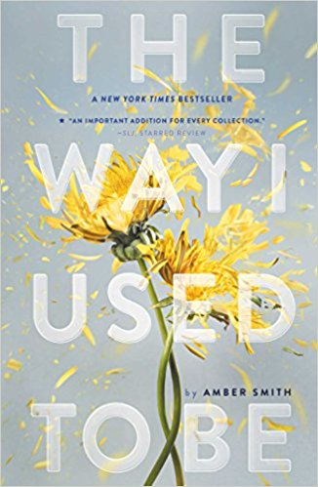
The Way I Used to Be
by Amber Smith

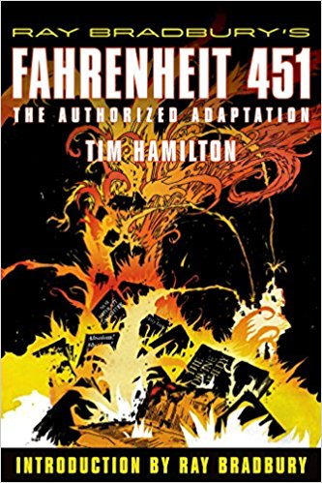
Ray Bradbury’s Fahrenheit 451:
the authorized adaptation
by Tim Hamilton

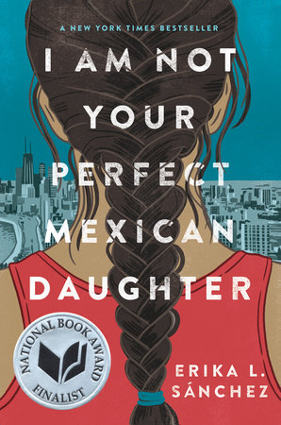
I am Not Your Perfect Mexican Daughter
by Erika L. Sánchez

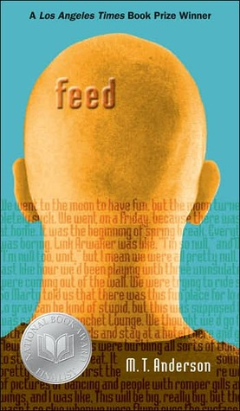
Feed
by M.T. Anderson

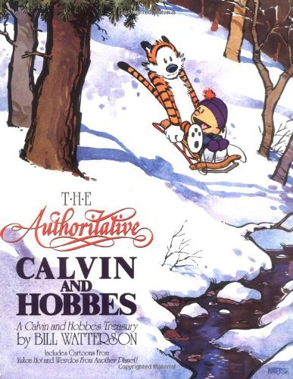
The Authoritative Calvin & Hobbes
by Bill Watterson

